Enhancing Machinery Health through Abnormal Data Detection with ASW and WMLOF

Report Submitted to SASTRA (Deemed to be University)

CSE 300 - MINI PROJECT

Submitted By

Balavignesh M-125158010
Kannan R-125158025
Krishna Sree Koushik G-125158027

( B.Tech Computer Science And Engineering IOT and Automation)

May 2024



SCHOOL OF COMPUTING
THANJAVUR, TAMILNADU, INDIA - 613401



SCHOOL OF COMPUTING

Bonafide Certificate

This is to Certify that the Report Titled as ”Enhancing Machinery Health through Abnormal Data Detection with ASW and WMLOF” submitted as the requirement for the course, CSE 300 - MINIPROJECT for B.Tech is the Record of the work done by Balavignesh M (125158010, B.Tech Computer Science And Engineering IOT And Automation), Kannan R ( 125158025, B.Tech Computer Science And Engineering IOT And Automation ) and Krishna Sree Koushik G (125158027, B.Tech Computer Science And Engineering IOT And Automation) during the academic year 2024-25, in the SCHOOL OF COMPUTING, under my supervision.

Signature of the Project Supervisor : 
Name and Affiliation : Dr.S.Raj anand
Date : 21/04/2024

ACKNOWLEDGEMENTS

We would like to thank our Honorable CHANCELLOR of our University
Prof. R. Sethuraman for providing us with an opportunity and the necessary infrastructure for carrying out this project as a part of our curriculum.

We would like to thank our Honorable VICE-CHANCELLOR of our University
Dr. S. Vaidhyasubramaniam and Dr. S. Swaminathan, Dean, Planning & Development, for the encouragement and strategic support at every step of our college life.

We extend our sincere thanks to Dr. R. Chandramouli, Registrar, SASTRA Deemed to be University for providing the opportunity to pursue this project.

We extend our heartfelt thanks to Dr.V.S. Shankar Sriram, Dean, SCHOOL OF COMPUTING, Dr. S. Gopalakrishnan, Associate Dean, Department of Computer Application, Dr.B.Santhi, Associate Dean, Research, Dr.R.Muthaiah, Associate Dean, Department of Information Technology and Information & Communication Technology.

Our guide Dr. Raj Anand.S, Associate Professor, SCHOOL OF COMPUTING was the driving force behind this whole idea of our project. His deep insight in this field helped us in making progress throughout our project work. We also thank the project review panel members for their valuable comments and insights which made this project even more better.

We would like to extend our gratitude to all the teaching faculties of the SCHOOL OF COMPUTING who have helped us in the completion of the project. We gratefully acknowledge and thank you all for providing me an opportunity to showcase my skills through this project.

ABSTRACT

In Machinery Health Monitoring (MHM), accuracy and reliability hinge on detecting abnormal data and enhancing its quality. Traditional methods struggle with MHM data dynamic nature. To overcome this, we propose the Adaptive Sliding Window (ASW) method, which prevents data leakage and redundancy. We introduce the Entropy Weighted Matrix, which assesses anomaly degrees across multiple scales by integrating local outlier factors comprehensively. Comparative analysis validates effectiveness, demonstrating their superiority over established algorithms. This adaptive approach excels in identifying abnormal data in MHM, outperforming previous methods. ASW and EWM on LOF holds promise for enhancing machinery reliability and maintenance practices in various industries.

Keywords: Local Outlier Factor,Adaptive Sliding window,Entropy Weighted Matrix

Table of Contents

Title Page No.
Bonafide Certificate i
Acknowledgements ii
Abstract iii
1. Summary of the base paper 1
2. Merits and Demerits of the base paper 2
3. Source Code 4
4. Output Snapshots 9
5. Conclusion and Future Plans 13
6. References 14
7. Appendix -Base Paper

CHAPTER-1
SUMMARY OF THE BASE PAPER

Title | : | Abnormal Data Detection Based on Adaptive Sliding Window and Weighted Multiscale Local Outlier Factor for Machinery  Health Monitoring
Publisher | : | IEEE
Year | : | 2022
Journal name | : | IEEE Transactions on Industrial electronics
DOI | : | 10.1109/TIE.2022.3231279
Base paper URL | : | https://ieeexplore.ieee.org/document/10002395

Notable contributions of the paper are:
- This paper abbreviates about the problems faced in machine health monitoring due to the increase in the size of the data and the shortcomings of the traditional anomaly detection algorithms and proposes a novel a novel method by using ASW,EWM and LOF.

Techniques used are:
- Adaptive Sliding Window: Unlike the normal sliding window this changes the length of the window actively depending on the requirement.
- Entropy Weighted Matrix: This method finds the uncertainty in the data .
- Local Outlier Factor: A density based abnormalities detection algorithm which highly depends on the number of neighbors and the threshold value.

CHAPTER-2
MERITS AND DEMERITS

LITERATURE SURVEY :

- “A comparative evaluation of outlier detection algorithm” by R.Domingues et al., The paper delves into the domain of unsupervised machine learning algorithms focusing on outlier detection, medical diagnoses, and data cleaning. This explains about the effectiveness and applicability in real-world scenarios. By verifying against publicly available datasets, it gives a comparative analysis of different algorithms. Further it uses ROC, precision-recall, computation time, memory usage and robustness to evaluate the algorithm.This method gives useful insights into the limitations of existing algorithms.

- “Effects of the entropy weights on TOPSIS” by P. Chen. The Order Preference technique by TOPSIS is discussed in the paper.TOPSIS is a well established method for decision making used in various domains. Entropy Matrix is combined with TOPSIS to find the attributes weight, which has significant effect on TOPSIS output.

- “A Survey of machine learning for big data processing” by J. Qiu et al., The recent advancement in machine learning by techniques like deep learning, distributed learning and representational learning. Scalability and data quality are the biggest issue to overcome. The paper delves into signal processing methods in managing big data.

MERITS AND DEMERITS:

MERITS:
1. The paper proposes a method which not only reduce the data leakage and redundancy but also finds the uncertainty in the data to minimize its influence on the result.
2. Integration of different techniques: ASW, EWM and LOF such Machine Learning Techniques and Novel methods are integrated here to increase the efficiency.
3. Scalability: Modern machines generated huge data which is hard to process. The enhanced method can handle such data effectively.

DEMERITS:
- By adding new methods for effective detection of anomaly the processing time has increased.
- Lof has a best case of nlog(n) which is not attainable with the new method.
- Finding the best suitable lambda value requires a lot of tuning.
- There are other algorithm which provides more effective detection in some cases.

CHAPTER 3
SOURCE CODE

3.1 DATA PREPROCESSING

import pandas as pd
import matplotlib.pyplot as plt
import numpy as np
from sklearn.neighbors import LocalOutlierFactor
df=pd.read_csv(r'C:\Users\Koushik\Desktop\Mini_Proj\archive\a.csv')
x = df['V_in']
y = df['Vibration_1']
X1, X2, y1, y2 = train_test_split(x, y, test_size=0.00077)
test= pd.concat([X2,y2], axis=1)
test

3.2 DATA VISUALIZATION

plt.scatter(X2, y2, marker='o', linestyle='-',s=1)
plt.xlabel('voltage')
plt.ylabel('vibration')
plt.grid(True)
plt.show()
df= pd.DataFrame()
df['v']=X2
df['vibration1']=y2
series=pd.Series(y2)

3.3 LOCAL OUTLIER DETECTION

mean_value = series.mean()
std_deviation=series.std()
model = LocalOutlierFactor(n_neighbors=40, contamination=std_deviation*.707+mean_value)
outlier_scores = model.fit_predict(df)
negative_outlier_scores = model.negative_outlier_factor_
print(outlier_scores)
df['anomoly']=outlier_scores
df['outlier_scores']=-negative_outlier_scores
plt.figure(figsize=(10, 6))
plt.scatter(df['v'], df['vibration1'], c=df['anomoly'], cmap='viridis', s=1)
plt.colorbar(label='LOF Score')
plt.xlabel('Feature 1')
plt.ylabel('Feature 2')
plt.title('LOF Density Plot')
plt.show()

3.4 ADAPTIVE SLIDING WINDOW

import math
def dist(a1,a2,b1,b2):
return math.sqrt((a1 - a2) ** 2+(b1 - b2) ** 2)
vibe=np.array(df['vibration1'])
volt=np.array(df['v'])
segments = []
current_segment = [vibe[0]]
c_volt=[volt[0]]
thershold=0
j=1
for i in range(1, len(vibe)):
distance = dist(vibe[i],current_segment[-1],volt[i],c_volt[-1])
if (((distance <= (thershold/j)*5 ) | (j==1))&(j<100)):
j=j+1
current_segment.append(vibe[i])
c_volt.append(volt[i])
thershold=distance+thershold
else:
j=1
segments.append(current_segment)
current_segment = [vibe[i]]
c_volt=[volt[i]]
thershold=0
segments.append(current_segment)

3.5 ENTROPY WEIGHTED MATRIX

from scipy.stats import entropy
import numpy as np
csegments=pd.Series(segments)
Div_k = [abs(1 - entropy(pd.Series(segment).value_counts(normalize=True))) for segment in csegments]
Div_k
print(len(Div_k))
wei=[(100*Div_k[i]/np.sum(Div_k[0:len(Div_k)]))+0*y for i,segment in enumerate(segments) for y in segment]
print("Weighted Matrix:")
print(wei)
print(len(wei))
df['weight']=wei

3.6 VISUALIZING ENTROPY WEIGHTS

n_anomoly=df[df['anomoly']==1]
n_anomoly
s_anomoly=df[df['anomoly']==-1]
plt.figure(figsize=(10, 6))
plt.scatter(n_anomoly['v'], n_anomoly['vibration1'], c=n_anomoly['weight'], cmap='viridis', s=1)
plt.colorbar(label='LOF Score')
plt.xlabel('Feature 1')
plt.ylabel('Feature 2')
plt.title('LOF Density Plot')
plt.show()
plt.figure(figsize=(10, 6))
plt.scatter(s_anomoly['v'], s_anomoly['vibration1'], c=s_anomoly['weight'], cmap='viridis', s=1)
plt.colorbar(label='LOF Score')
plt.xlabel('Feature 1')
plt.ylabel('Feature 2')
plt.title('LOF Density Plot')
plt.show()

3.7 WMLOF

uw=[]
for i,w in enumerate(df['weight']):
uw.append(w*.5*-negative_outlier_scores[i])
wei=pd.Series(uw)
t=pd.Series.std(wei)+pd.Series.mean(wei)
updated_anomoly=[]
j=0
for i,w in enumerate(df['weight']):
if (w>t):
j=j+1
updated_anomoly.append(outlier_scores[i]*-1)
else:
updated_anomoly.append(outlier_scores[i])
#print("else")
df['ua']=updated_anomoly
plt.figure(figsize=(10, 6))
plt.scatter(df['v'], df['vibration1'], c=df['ua'], s=1)
plt.colorbar(label='LOF Score')
plt.xlabel('Feature 1')
plt.ylabel('Feature 2')
plt.title('LOF Density Plot')
plt.show()

3.8 COMPARING LOF AND PROPROSED METHOD

from sklearn.metrics import silhouette_score
clusters = np.where(outlier_scores == -1, 0, 1)
silhouette_avg = silhouette_score(df,clusters)
print("The average silhouette_score is :", silhouette_avg)

clusters = np.where(df['ua'] == -1,0, 1)
silhouette_avg = silhouette_score(df,clusters)
print("The average silhouette_score is :", silhouette_avg)
CHAPTER 4
OUTPUT SNAPSHOTS

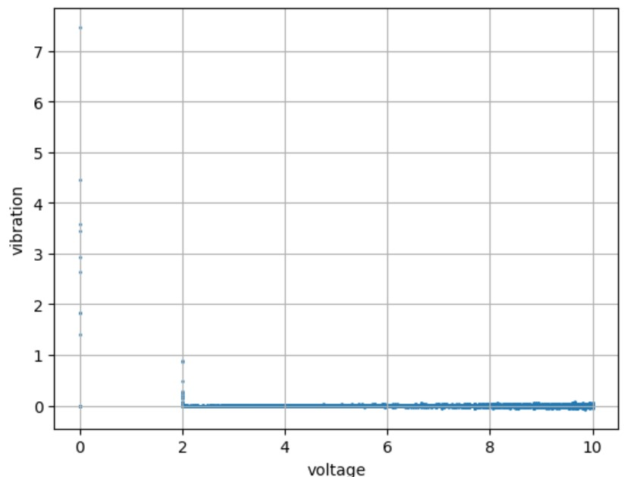

Fig 4.1

Fig 4.1 shows the relation between voltage and vibration of the rotating shaft

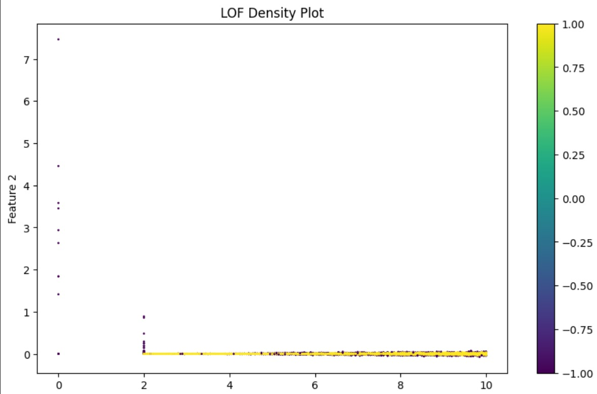
Fig 4.2
Fig 4.2 differentiates anomaly points and normal points where yellow dots represents normal data points and violet dots represents anomaly points

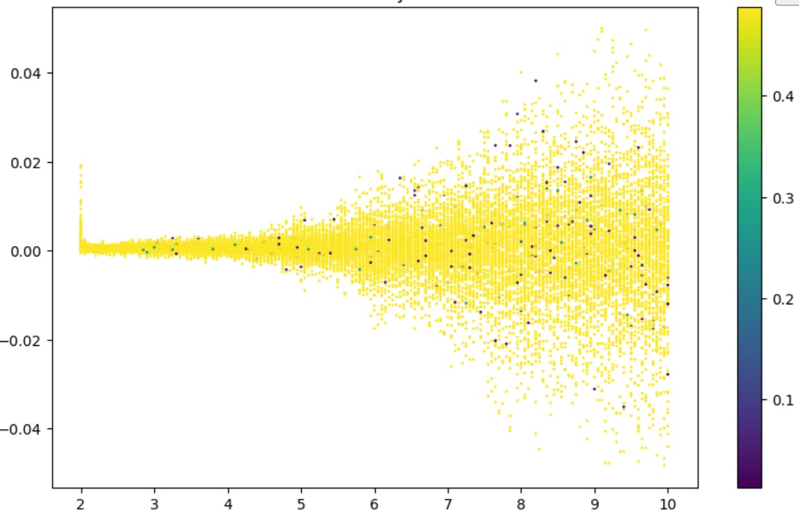
Fig 4.3
Fig 4.3 depicts the entropy value of the anomaly points using the suggested Entropy Weighted Matrix method

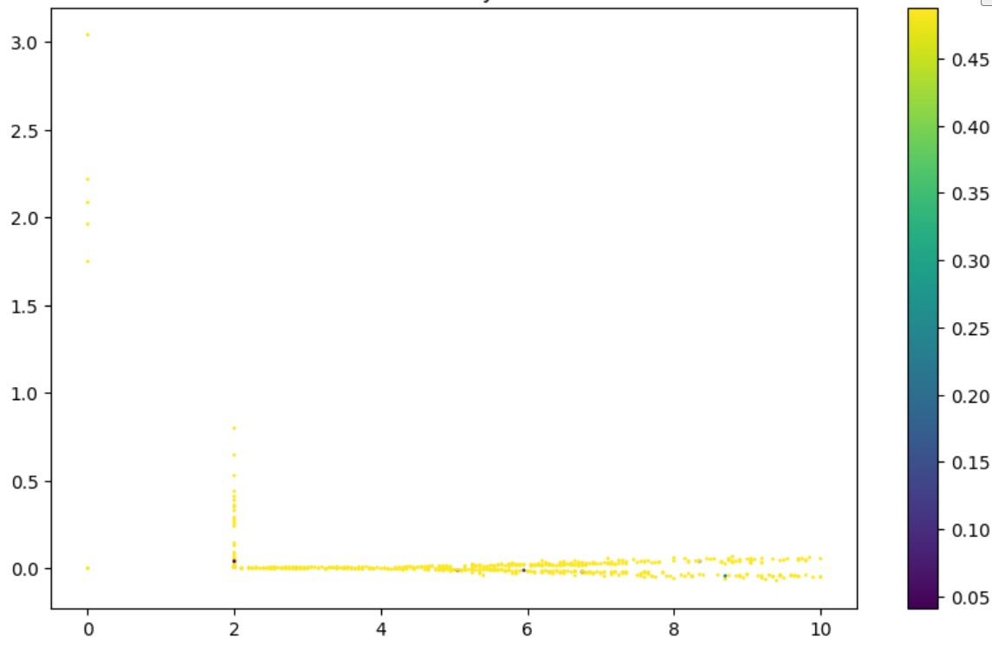
Fig 4.4

Fig 4.4 show the entropy value of the normal data points

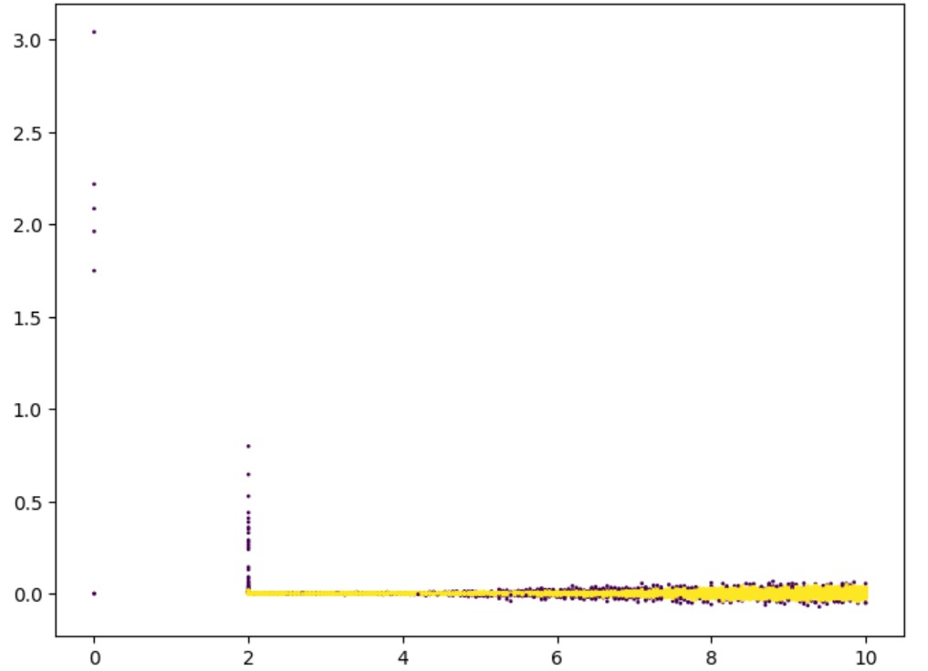
Fig 4.5

Fig 4.5 picturizes the updated anomaly points found using the enhanced algorithm.

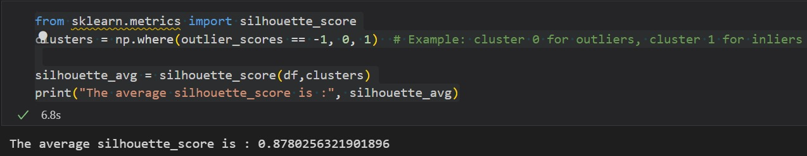
Fig 4.6
Fig 4.6 gives the silhouette score of the normal LOF algorithm (silhouette score is a clustering metrics used for finding how well the clustering is done)

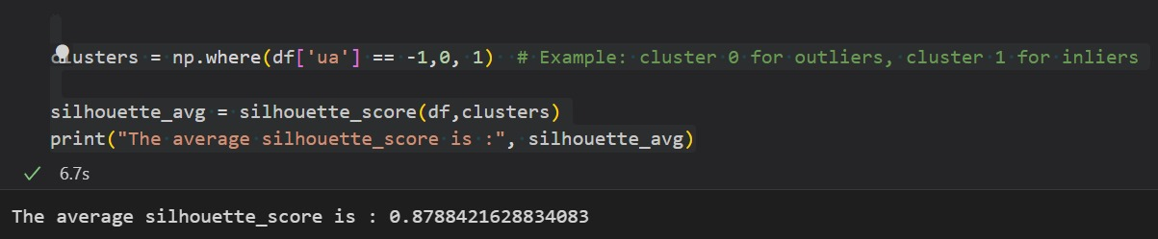
Fig 4.7
Fig 4.7 reveals the improved silhouette score of the Weighted Matrix Local Outlier Factor(WMLOF)

CHAPTER 5
CONCLUSION AND FUTURE PLANS

The proposed method for anomaly detection using EWM,ASW AND LOF has significant potential for increasing data quality and reduce uncertainty in the data.It effectively detects slight anomaly signals.In the field of machine health monitoring such qualities are essential to prevent machinery faults.Further we can increase the efficiency to find anomalies meeting the real time demand of the practical machinery health monitoring and to make this algorithm suitable for any kind of machinery data.

REFERENCES

- Y. Lei, F. Jia, J. Lin, S. Xing, and S. X. Ding, “An intelligent fault diagnosis method using unsupervised feature learning towards mechanical Big Data,” IEEE Trans. Ind. Electron., vol.63, no. 5, pp. 3137–3147, May 2016.

- Q. Xie, G. Tao, B. He, and Z. Wen, “Rail corrugation detection using one-dimensional convolution neural network and data-driven method,” Measurement, vol. 200, 2022, Art. no. 111624.

- R. Kumar et al., “Revealing the beneﬁts of entropy weights method for multi-objective optimization in machining operations: A critical review,” J. Mater. Res. Technol., vol. 10, pp. 1471–1492, Jan./Feb. 2021.

- I. Hussain, “Outlier detection using nonparametric depth-based techniques in hydrology,” IJACSA, vol. 11, no. 9, pp. 456–462, 2020.

- O. Avci et al., “A review of vibration-based damage detection in civil
structures: From traditional methods to machine learning and deep learning
applications,” Mech. Syst. Signal Process., vol. 147, 2021, Art. no. 107077.

- Q. Zhu, J. Feng, and J. Huang, “Natural neighbor: A self-adaptive neighborhood method without parameter K,” Pattern Recognit. Lett., vol. 80,pp. 30–36, Sep. 2016.

- A. Wahyudi, G. Kuk, and M. Janssen, “A process pattern model for tackling
and improving Big Data quality,” Inf. Syst. Front., vol. 20, pp. 457–469,
Jan. 2018.

- G. H. Tzeng and J. J. Huang, Multiple Attribute Decision Making: Methods
and Applications. New York, NY, USA: Springer-Verlag, Aug. 2011.

CHAPTER 7
APPENDIX

BASE PAPER: Abnormal Data Detection Based on Sliding Window and Weighted Multiscale Local Outlier Factor for Machinery Health Monitoring

DOI: 10.1109/TIE.2022.3231279

Keywords: Adaptive sliding window,Entropy weighted matrix,Local outlier factor

URL: https://ieeexplore.ieee.org/document/10002395

